**ESKISEHIR TECHNICAL UNIVERSITY**

-COMPUTER ENGINEERING DEPARTMENT-



NeYapsam

***BIM423 - Software Engineering***

* Ahmet Kurt - 30581370704

***Teacher : Assoc.Prof.Dr.Özgür YILMAZEL***

28/12/2018

**-** **ABSTRACT -**

This document contains informations and analysis of “NeYapsam” project which is project of BIM423 - Software Engineering lecture. There are details about the project under the following titles.

Contents

i. ABSTRACT 1

ii. PROJECT OVERVIEW 3-5

ii.A. Motivation 3

ii.B. Definition 3

ii.C. Group Members 3

ii.D. Timeline 3-4

ii.E. Work Distribution 5

iii. REQUIREMENTS 6

iii.A. User Requirements 6

iii.B. System Requirements 6

iii.B.1. Functional Requirements 6

iii.B.2. Non-functional Requirements 6

iii.B.2.1. Product Requirements 6

iii.B.2.2. Organizational Requirements 6

iii.B.2.3. External Requirements 6

iii.B.2.4. Usability Requirements 6

iv. DEVELOPMENT 7-11

iv.A. Database Development 7-8

iv.A.1. Requirement Analysis 7

iv.A.2. Conceptual Database Design (EER Diagram) 8

iv.A.3. Logical Database Design (Conceptual Schemas) 8

iv.B. Xamarin Development 9

iii.A.1. Requirements 9

iii.A.2. Design 9-11

v- REFERENCES 12

**-** **PROJECT OVERVIEW -**

# **A.** **Motivation**

This project was motivated by an issue we faced during daily life. People spends lots of money by ordering foods even if they have proper ingredients to cook those foods. The reason is that they do not know what can they prepare by using their ingredients. In this project, we aimed to offer food list for each user to make them know which foods they are able to prepare.

# **B.** **Definition**

Ne Yapsam is a useful project to evaluate your foods. By using this, people can reap a profit and cook delicious foods. Our team's goal was that making a useful application to help people on preparing dishes at home in this project. Application follows your food stock at home and gives you some suggestions at 'What to make for meal?

# **C.** **Group Members**

* Fırat Deniz Ardahan
* Ömer Kaya
* Zelimhan Önlü
* Ahmet Kurt
* Soner Ceylan
* Magomed Salakh Lorsanov
* Cihan Mutlu

# **D.** **Timeline**

### **Week - 1 :**

* Join a group for project

### **Week - 2 :**

* Topic specification
* Design a website

### **Week - 3 :**

* Requirement Analysis for Database
* Conceptual Database Design

### **Week - 4 :**

* Logical Database Design

### **Week - 5 :**

* Prototype Database
* Prototype Application

### **Week - 6 :**

* Database - UI
* Requirement Analysis for Application
* Use Cases for Apllication
* Xamarin - UI

### **Week - 7 :**

* Database - Development
* Xamarin - Development

### **Week - 8 :**

* Database - Development
* Xamarin - Development
* Graphic Design

### **Week - 9 :**

* Xamarin - Development
* Testing

### **Week - 10 :**

* Testing
* Bug Fixes

# **E.** **Work Distribution**

1. **Ömer Kaya**

* Xamarin – UI
* Requirement Analysis for Application
* Use Cases for Apllication
* Xamarin - Development

1. **Fırat Deniz Ardahan**

* Requirement Analysis for Application
* Use Cases for Apllication
* Xamarin - Development

1. **Ahmet Kurt**

* Design a website
* Prototype Database
* Prototype Application
* Database - UI
* Database - Development

1. **Zalimhan Argun Önlü**

* Prototype Database
* Prototype Application
* Database - Development

1. **Magomed Salakh Lorsanov**

* Prototype Database
* Prototype Application
* Database - Development

1. **Cihan Mutlu**

* Enter Datas to Database

1. **Soner Ceylan**

* Database - Development
* Design Proper Graphics for Application

**-** **REQUIREMENTS -**

# **A.** **User Requirements**

* User should register Ne Yapsam to take advantages of application.
* User should enter his/her ingredients to get a food list which he/she can cook by using those ingredients.

# **B.** **System Requirements**

* System should provide proper food list to say users to make them know what kind of foods they can prepare.
* System should provide alternative food list if user suplies missing ingredients.
* System should provide registration capability to the users.

**B.1.** **Functional Requirements**

* Registered users will be able to select ingredients.
* Registered users will be able to search foods which they can cook.

**B.2.** **Non-functional Requirements**

**B.2.1.** **Product Requirements**

* Ne Yapsam should be able to use on all platforms.

**B.2.2.** **Organizational Requirements**

* Users should make a gain after using Ne Yapsam Application.

**B.2.3.** **External Requirements**

* The system has to make guarantee users privacy.

**B.2.4.** **Usability Requirements**

* Ne Yapsam should be easy to use.
* Ne Yapsam should has rapid user response capability.

**-** **DEVELOPMENT -**

# **A-** **Database Development**

**A.1.** **Requirement Analysis**

* We have an aplication which give some suggestions to users for cooking meals by using their ingredients.
* In this database we keep track datas about users, foods, ingredients and stores.
* Our aplication’s users have their user id which is unique for them. Also users have usernames,passwords and locations.
* Also we have foods and they have names and their unique ids. There are kind of foods which are salads, soups, desserts and main foods. These foods can be eaten in different meals of the day.Meals have names and ids which are spesific for each meals.
* In addition to foods we have ingredients for cooking foods. There are six types of ingredients which are meats, animal products, vegetables, fruits, spices and others. Each ingredients have their unique ids, names and calories.
* Lastly, There are stores for providing ingredients to users. These stores has their unique ids. Also they have names and locations.

**A.2.** **Conceptual Database Design (EER Diagram)**

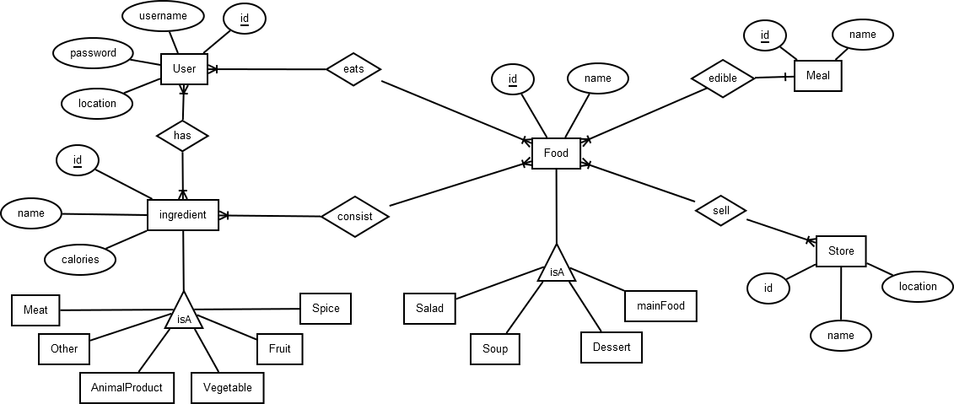

**A.3.** **Logical Database Design (Conceptual Schemas)**

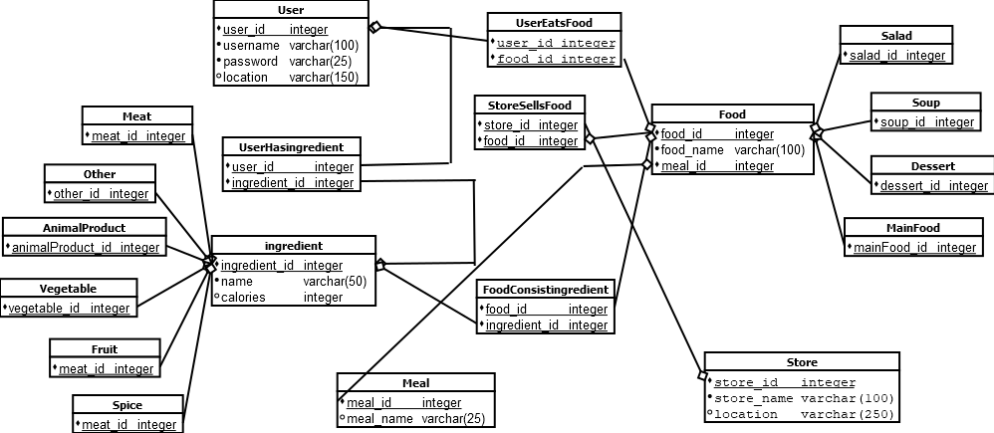

# **B-** **Xamarin Development**

**B.1.** **Requirements**

1. User Interface
2. Main Page
3. Menus
4. User Info
5. Stock
6. Account Settings
7. Profile
8. Search
9. Stock Editing
10. Ingredients
11. Local Shops

**B.2.** **Design**

When users entered application, sign up (left) and log in (right) pages will be look like :

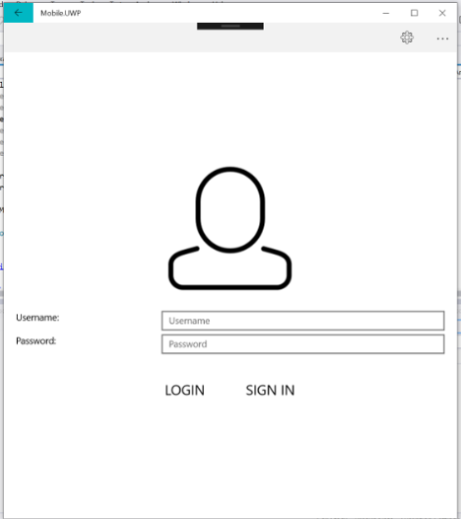 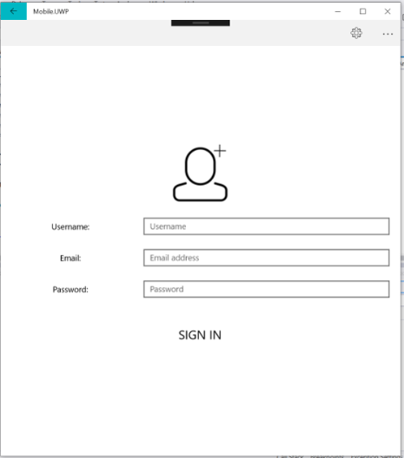

After sign up or login, food page will be look like :



Adding ingredients page will be look like :

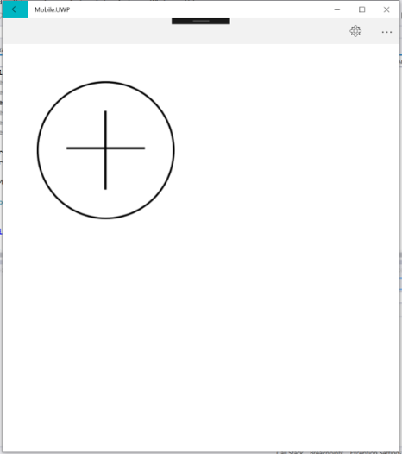

Ingredients page (left) and users’ ingredients page (right) will be look like :

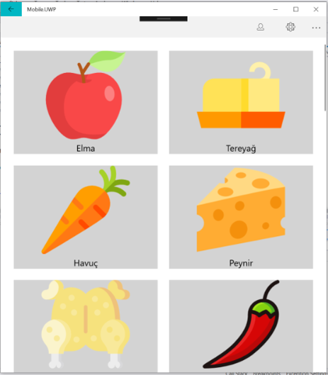 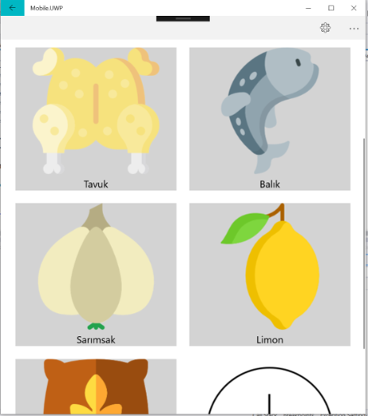

After ingredients are selected foods page will be look like :

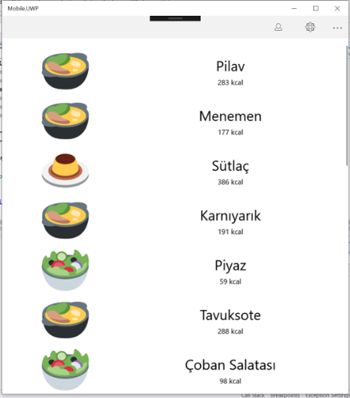

**-** **REFERENCES -**

* <https://visualstudio.microsoft.com/xamarin/>
* <https://university.xamarin.com/>
* <https://en.wikipedia.org/wiki/Mobile_app_development>
* <https://www.back4app.com/docs/platform/get-started/cloud-database>
* <https://firebase.google.com/docs/>